Raqs Media Collective and the Powers and Textures of the False
Alina Khakoo
December 2018

Introduction

The guiding principle of this essay is that artworks can have ideas that words cannot or have not yet expressed. When the Delhi-based Raqs Media Collective taught an MA course at the School of Arts and Aesthetics, Jawaharlal Nehru University in 2011, they entitled their lecture series ‘The Traffic of Images and the Tangle of Thought’. This title encapsulates the conception of thought that this paper supports, whereby material articulation can enable ideas to become ‘entangled’, and the embodiment of concepts can urge them to obstruct one another in ‘traffic’. The moving images discussed in this paper formulate thought in palpable and dynamic forms, rather than scripting concepts on a page.

The theory incarnated by these works confronts a history of contending truths that shaped colonised South Asia. Edward Said has stated that colonial regimes operated according to a ‘system of truths’, gathering anthropological and other evidence to enforce knowledge and control over ‘natives who were illiterate, disputatious, wily, deceitful, and to the eyes of the European all looked the same’. This paper expands on how the British Raj legitimised its authority and assuaged its colonial anxiety by using ontological and empirical evidence such as dactylography or fingerprinting, photography and anthropometrics. Its determination to establish hard truths about colonised subjects reveals that truth is not a transcendental ideal but a willed human strategy, resonating with Friedrich Nietzsche’s 1873 essay, ‘On Truth and Lies in an Extra-Moral Sense’, which argues that truth is an act by which the ‘regularly valid and obligatory designation of things is invented’. The philosopher undermines objective conceptions of truth by arguing that the tactical ‘urge for truth’ has given credence to ideologies such as ‘true knowledge, true morals, true religion’ – to which we might now add ‘true indigenous identity’.

One mode of resistance against the colonial ‘system of truths’ has consisted of promoting the people’s truth, as in Mahatma Gandhi’s Hind Swaraj or Arundhati Roy’s 2003 statement that the legacy of empire must be countered with ‘our own stories, stories that are different from the ones we’re being brainwashed to believe’. However, Raqs Media Collective contends that this strategy merely replaces one authoritarian truth claim with another, rather than intervening in the logic of power. Evoking Nietzsche, the group maintain that the function of truth is to ‘register and index a stable picture as power wills it to be’. Therefore, discourses that consider subversion to be the propagation of alternative truths, such as the conventional documentary, must ‘produce in turn images and representations that are well organised and persuasive and that conform to the approximation of truth from the perspective of power’. Also recalling Partha Chatterjee’s argument that Indian nationalism was caught in the double bind of opposing colonial power and making itself in the coloniser’s image, Raqs upholds that to counter the British Raj’s truth with the Indian subjects’ truth is to remain confined in the structure of power relations established by the coloniser.

In an interview with Hans Ulrich Obrist after the Mumbai attacks in 2008, the artists stated that the groups exerting violence today have held onto the violence enacted against them, a cycle that has created not a ‘cosmic war’ but a ‘harsh banality’, so that resistance is not a radical practice but a deadly and deadened act of circulating violence and power. Raqs are opposed to such an uncreative and unproductive mode of critique, and thus their works operate otherwise. This paper hopes to demonstrate that when Raqs confront colonial truth claims about Indian identities and bodies, they do not wage a circular truth war; instead they consciously ‘seek refuge from certainty’, having stated that what brings them together every day is to ‘cultivate a daily and diligent garden of doubt, from which we harvest many different kinds of fruits and flowers’. They articulate this escape from truth to doubt using vivid imagery, conjuring the colour, form, shape and perfume of a garden to envision the generative properties of doubt, which may yield gustatory, tactile and vibrant fruits and flowers. This paper explores Raqs’ philosophy that abandons the colonial truth regime and instead pursues the fertile pathways opened up by doubt, uncertainty and the false, using close reading to pay attention to the textures of this theory incarnate.
The powers of the false:
The Untold Intimacy of Digits

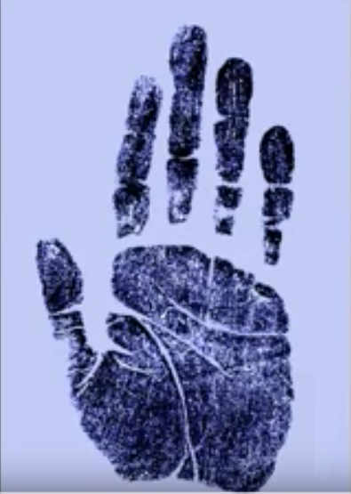
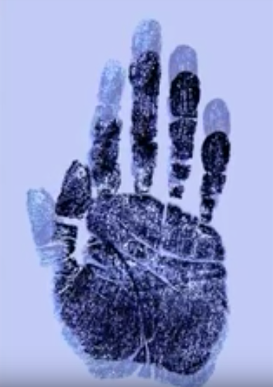
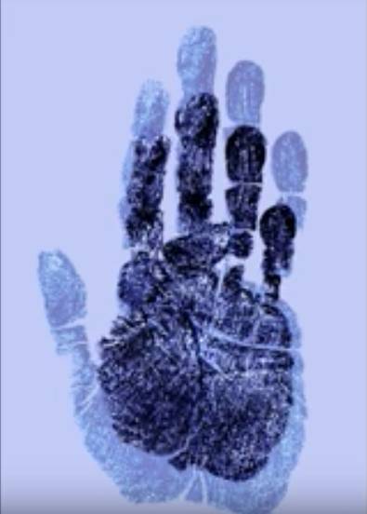
1-3. Stills from The Untold Intimacy of Digits. YouTube.

Raqs’ The Untold Intimacy of Digits (2011) consists of a 1-minute looped video projection of an animated blue handprint gesturing against white ground. It treats the history of colonial dactylography or fingerprinting, a science dedicated to securing the truth about Indian society. The technology was developed by the British colonial magistrate William James Herschel, who stated that he held a ‘distrust of all evidence’ tendered to him in court in Jungipoor. In 1858 he accepted a tender to supply road building material from a villager named Rajyadhar Konai, and where other colonial administrators had attempted to secure truth using life and death casts or ‘paper squeezes’, Herschel demanded an ink stamp of Konai’s hand as a trustworthy contract. He conducted further experiments on this newfound mode of documentation, isolating the fingertip as the container of the most complex information, and exported these findings to the scientist and eugenicist Francis Galton in England. By 1891, the entire Bengal police had taken up fingerprinting, on which occasion Herschel praised the inspector general for his part in ‘fashioning a weapon of penetrating certainty for the stronger needs of justice’. In this instance, as Nietzsche suggests, truth, certainty and evidence are not essential values but ‘weapons’ for colonisers to administer colonial subjects. This excerpt from the history of the British Raj demonstrates the conviction that truth is not an abstract concept but an agent in the consolidation of power; the appropriate response suggested by Raqs is not to impart a more valid truth about colonial subjects, but to engage in ‘guesswork’.

Untold Intimacy was exhibited at Raqs’ Guesswork exhibition at the Frith Street Gallery in London in 2012. The title of the exhibition points out part of what makes the work so subversive: where the handprint represented trust, certainty and honesty for Herschel, Galton and the colonial police, Raqs broaden its scope to accommodate doubt. The artists use digital animation to wrest the print from its home in the colonial archive at University College London, and recast it as a monumental blue handprint that slowly furls and unfurls, touching its thumb to each finger one by one, in an on-going looped sequence. As the exhibition theme indicated, the viewer can only use guesswork to understand the handprint, which transmits ambiguous clues. The thumb and fingers seem to be counting arithmetic, for example, but could also be communicating in sign language; the work seems to be the kinetic resurrection of a hand that has remained static for over a century, but the editing engineers a stilted and robotic rather than smooth and vital movement, so that it is neither wholly embodied nor disembodied. In her interpretation of the work, Natasha Eaton observes that the hand relates at once to the subaltern Konai and the divine hand of Fatima, evil eye, open hand imagery in Indian national iconography and magic of palmistry. In Blue Mythologies, Carol Mavor argues that blue is a ‘paradoxical colour’, as ‘blue is the purity of the Virgin Mary, yet blue names a movie as obscene’, and ‘blue is the colour of eternity, yet blue lips are a sign of approaching death’. Eaton has also pointed out that in South Asia, blue relates to indentured labour on colonial indigo plantations and the violence of the resulting ‘blue revolution’ uprisings, but the toxic substance is also associated with reparation, as indigo has long had a medicinal use in the treatment of snakebites and setting broken bones. In Untold Intimacy, these divergent connotations are conjured simultaneously. Altogether, the artists’ choice of colour, animation and gesture creates a melee of semiotic aporia that the viewer can only guess at deciphering. This ruptures with the handprint’s original function as the purveyor of clear and direct truth: where Herschel argued that ‘the impression of a man's finger on paper cannot be denied by him afterwards’, the impression presented here constantly contests its meaning. Where the handprint was formerly construed as a blueprint for the individual, Raqs’ work is a blue print, tearing the concept apart from within and creating space for transparent meaning to drop into obscurity.

The irony about Raqs is that although the collective ‘seeks refuge from certainty’, as what brings them together every day is to nurture a ‘garden of doubt’, they are surprisingly involved in the interpretation of their works. They comment on pieces such as Untold Intimacy at lectures and conferences and in dossiers published on their website, where they also repost academic papers on their works. They designate terminology to discuss their works, such as ‘recension’, the constant revision of texts that propagates an on-going creative dialogue, and ‘surjection’, a mathematical set that transposes the qualities of one quantity onto another. Even the titles of works such as Untold Intimacy guide the viewer’s understanding, conveying a paradoxical sense of intimacy and withdrawal from communication, and playing on the word ‘digit’ to refer to fingers, numbers, biometrical data drawn from fingerprints, the gesture of counting and digital animation. In an interview, Raqs member Shuddhabrata Sengupta provided his annotation that the abbreviated title UID relates to the acronym for the Indian government’s biometric database, which is in the process of cataloguing the entire population. He laments that this scheme is ‘bound to fail and will in its wake create terrible tragedies’, not to mention the irony of continuing work begun with the intention of colonial governance. It is clear that Raqs’ dedication to sowing seeds of doubt rather than elucidating truth does not make them reluctant to explain their work. Perhaps this reveals distrust in their critics, or perhaps it is a strategy: the more information the viewer receives, whether through academic studies, interviews or presentations, the more she loses her grasp on the work. It appears that Raqs do not so much determine as overdetermine their practice, layering various terminologies and conceptual frameworks to produce a dense and often times confusing exegesis, much as Untold Intimacy layers a moving handprint over the static handprint from the archive. In both cases, the imbrication of information causes the original to blur.

Raqs’ use of the blur, the false and the doubtful goes further than countering the colonial regime of truth, certainty and transparency with its opposites. The group’s conception of the false is not quite the binary opposite of true, as to counter true with false would be to upend a system rather than break out of it. Instead, Raqs’ practice seems to resonate with Gilles Deleuze’s theory of the ‘powers of the false’, dispersed throughout his writings but given sustained attention in Cinema II. Deleuze argues that Nietzsche’s most important discovery was not to point out the falseness inherent in truth, but to infer that the false has the singular power to faire faux: to create, invent or make exist. That he reinvents the theory as falsification, storytelling and fabulation encapsulates how the false is the most creative enterprise: it can never atrophy, for as soon as it becomes fixed as true, it loses its function and must be invented anew, demanding the perpetual creation of new discourse. In Untold Intimacy, the artists also conceive of the false not as the circular replacement or inversion of truth but as a constant metamorphosis of expression or becoming. The looped video, which has no start or end, launches this gesture to infinity. Even the video projection cannot be seen as the end product of an artistic process, as it functions instead as one point in Raqs’ ever-expanding practice. The other nodes in this network include researching, combing through the Galton Archive at University College London, constructing a digital animation of the handprint, curating exhibitions, composing accompanying text and presenting on the work; the viewer, who only ever enters the work in the middle, can be sent in any of these directions. The notion of an open project is at the core of Raq’s practice, as they have stated that their collective of three artists represents that ‘there is me, (one), there is you, (two), and then there are many, (three)’. Their triadic grouping enables the artists to break out of a monotonous dialectic and expand into open plenitude.

Untold Intimacy constantly assumes new incarnations and meanings, and although this paper frames it as a response to the colonial truth regime, it cannot even be reduced to this, as it is also pertinent to contemporary politics such as the state-sponsored fingerprint database in India. The work resists any co-option by the truth regime, including the conventional mode of academic critique that has been theorised variously as ‘the hermeneutics of suspicion’ or ‘paranoid reading’, whereby scholars overturn surfaces and search for clues in order to expose the ‘true’ workings of an object of study, an exercise not so distant from other pretences of conjecture and evidence. Untold Intimacy prevents the critic from being another agent of truth, for as soon as she has a lucid understanding of the work, it again steals into doubt, ambiguity and obscurity. The powers of the false are summoned to catalyse a becoming, which ensures that the work does not congeal into dogma or cliché.

The textures of the false:
The Surface of Each Day is a Different Planet

Thus far, I have only subtly supported my opening statement that the visual has the power to render philosophy in palpable and dynamic configurations, as Untold Intimacy sees Raqs materialise and mobilise a theoretical abandonment of the truth regime and an escape to the powers of the false. The upcoming section concentrates more acutely on how the artists give physical form to their philosophical tenets about truth and fabulation, enabling these concepts to come into closer contact and confrontation in the 38-minute video work, The Surface of Each Day is a Different Planet (2009), commissioned for Tate Britain’s Art Now Lightbox series.

Where Untold Intimacy deals with dactylography, Surface treats ethnographic and anthropometric photography. Christopher Pinney has conducted extensive research into the historical moment before dactylographic technology was employed to subject mysterious Indian subjects to ‘penetrating certainty’, when photography was used to enforce ‘stern fidelity’ to the same ends. The perceived trustworthiness of photography was deduced mostly from what CS Peirce later theorised as the indexical function of the photograph, lending the medium what Roland Barthes has termed ‘an evidential force’ and a ‘power of authentication’, voiced over a century earlier by colonial administrators including Norman Chevers, Principal of the Calcutta Medical College. His 1856 book chapter ‘What is truth?’ lamented the ‘uncertainty of general evidence in India’, and resolved that ‘there could be scarcely a doubt that PHOTOGRAPHY would, before many years elapsed, be employed throughout India as a means of reproducing and identifying bodies’. This prediction soon materialised after the 1857 anticolonial insurrection in Bengal, when the crown published The People of India, a catalogue of Indian tribes and castes that presented photographs as forensic evidence of each group’s social and political identity, such as the dishonest but useful Baniya merchants who are caught in the act of deceiving customers. The colonial imagination also saw photography as an apparatus of truth because it could render subjects in precise mathematical proportion; several colonial photographs include a measuring stick along the picture edge or a square grid background, either as a prop or to provide scale. Many of these so-called physiological photographs were converted into vast indexes of anthropometric measurements by researchers such as Galton, Cesare Lombroso and Paul Broca, who in turn proved racist claims about the characteristics of each group. These findings again confirm Nietzsche’s conviction that truth is not a neutral abstraction but a ‘mobile army’, deployed here for imperial governance.
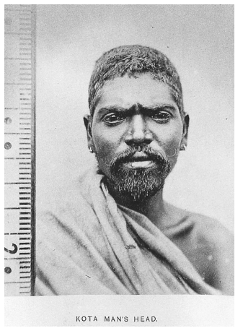
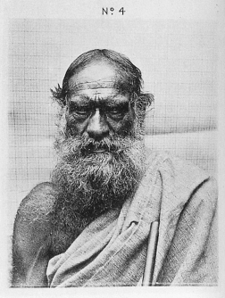

4-5. Photograph from J. W. Breeks, An Account of the Primitive Tribes and Monuments of the Nilgiris. 1873; Photograph From W. E. Marshall, A Phrenologist amongst the Todas. 1873.

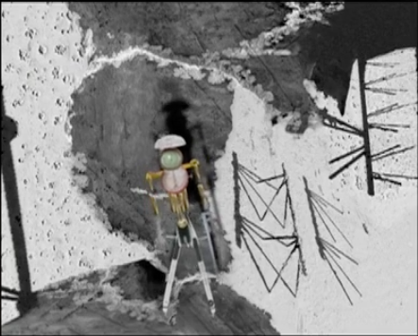
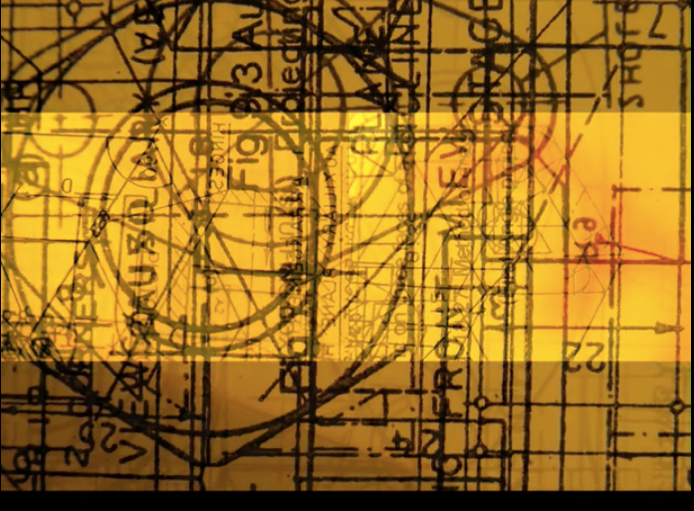
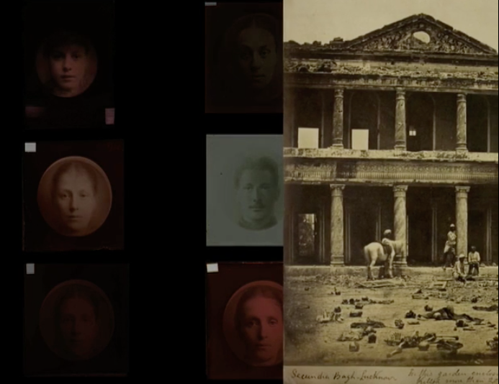
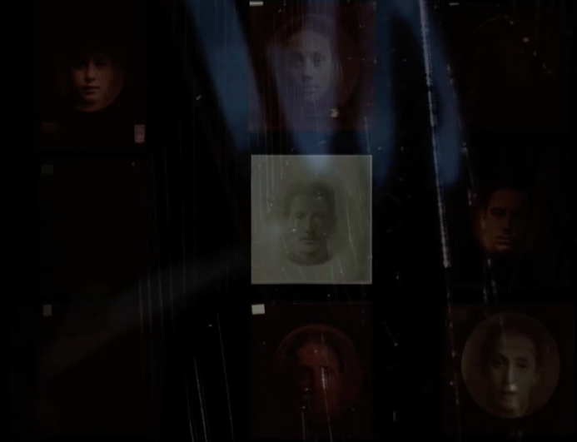

6-9. Stills from The Surface of Each Day is a Different Planet. Vimeo.

Raqs handle this violence in Surface using the powers of the false, reworking the colonial histories of anthropometry and photography into a network of micro stories that are engaged in a constant becoming. The work comprises an elaborate narration spoken by the artists, and a montage of images and video clips set against a black background. The images that recur most frequently are Galton’s composite photographs, used to identify types amongst the colonised, criminalised and sick, which are placed in constantly changing configurations and contexts. Not only do the artists alter the layout of these images each time, but they also invent shape-shifting stories about them, in one instance describing the researcher in the ‘crowded lab’ with ‘tired assistants’ in feverish pursuit of ‘the keys to the mysteries of the locked cabinet of human character’, and later delivering a fabulation about how criminal mug shots become saintly icons. In another sequence, the artists verbally excavate the bones that were measured by colonial scientists, such as phrenologists who used cranial measurements to prove the inferior intelligence of indigenous peoples. Raqs name each bone one by one, from the skull to the tibia, in a slow and deliberate incantation that unbinds them from colonial anthropometrics and releases them into the freedom of fabulation. The bones then take on imaginative new roles, such as rebars from an abandoned factory that resemble a paleontological skeleton, and the anatomy of a burned out car. Another sequence superimposes diagrams drawn up by colonial researchers so that they form moving cosmic constellations, and at the triumphant end of the piece, the instruments used by colonial scientists to measure body parts are unearthed from the archive and recast using digital animation. The epilogue consists of a two-pronged cranial measuring instrument reimagined as a ‘cosmonaut’ walking across craters, disappearing into shadow and reappearing in metamorphosing landscapes. In this work even more so than in Untold Intimacy, the artists delight in the open ontology and free interpretation of fabulation, which prevents creativity from ever becoming stuck as an authoritarian monolith such as truth. These sequences are radical in emancipating photography from its former operation of proving hard facts about the colonised body, and instead encouraging incoherence and the interchange of guises.

The moving image enables the artists to imagine this constant regeneration as an intensely material process. In Death 24x a Second, Laura Mulvey responds to Barthes’ frustration with the relentless movement of film that prevents prolonged absorption by defending that the power of both analogue and digital moving images is to embody an ‘insubstantial and irretrievable passing’. In contrast to the fixed photograph or stable words written on a page, the moving image incarnates forms and concepts that have an ‘elusive’ beauty and intrigue that slip out of the viewer’s grasp ‘like running water, fire or the movement of trees in the wind’. Surface consists of forms and concepts that are constantly dissolving and reincarnating before the eyes of the spectator, opening with the former as the artists utter the single word ‘Fire’. They then narrate an incendiary story about a hungry god who craved a roasted forest, so that ‘every beast that ever walked in that forest was incinerated as the hungry god feasted’. This story of erasure is paired with a single image of an abstracted rock face, which can be described most aptly as aniconic or non-representational. The opening sequence of Surface cremates both narrative and representation, providing fertile ground for the invention of new forms. This trajectory of disintegration and regrowth continues throughout the work, as montages appear and disappear in new configurations, punctuated each time by a long pause and blank screen, until the measuring-instrument-turned-cosmonaut decomposes in the closing sequence, its hands dropping off, torso collapsing, head rolling down the arms and each armature of the protractor buckling, before rising from the ashes as an aniconic image that marks the video’s end. In light of the colonial truth regime’s demand for photography and anthropometry to be stable referents, Raqs is subversive in reimagining these technologies as volatile. The moving image expresses this theory in material form, as histories and concepts are rendered as constantly metamorphosing bodies that deconstruct and reconstruct.

Finally, Surface operates not as a teleological or cohesive structure but a network of knots and lines, whereby the materiality of the moving image enables the artists to configure complex relations between these embodied phenomena. For instance, the artists enhance Sergei Eisentein’s famous claim that ‘montage is an idea that arises from the collision of independent shots’, juxtaposing unrelated images to create a productive ‘conflict’. In Surface, images literally crash into one another, such as when Felice Beato’s 1858 photograph of the aftermath of the massacre at Secundra Bagh enters from the right of the screen, forcing its way past the reproductions of Galton’s photographs. This interaction produces a conceptual friction between Galton’s veneration of the photographic index and Beato’s fabricated photograph, art historians having established that it includes skeletons too polished and clean to have been massacred only four months earlier. Where Galton and colonial administrators conceived of the photograph as having an incontestable ‘this-has-been’ status, the photograph of Secundra Bagh physically and theoretically disturbs this, pushing Galton’s negatives aside. Elsewhere in Surface, Galton’s photographs are superimposed by aniconic images, such as extreme close-ups of the sea, beach or a metal gate, so that the indecipherable image again physically and conceptually casts doubt over the decipherable image. Another concatenated arrangement comprises Galton’s photographs, blurred images of moving vehicles in a city and an urban soundscape of sirens, traffic and barking dogs, overwhelming the viewer’s sight and hearing to usher the thematics of the work into her immediate environment. This sequence connects the indexing of individuals to contemporary projects in the same vein, such as passport recognition technology and the Indian UID anthropometric database, which also render humans into ciphers, so that our social representation continues to consist of digits, shapes, colours and sounds. As the opaque title The Surface of Each Day is a Different Planet insinuates, each sequence is its own planet, with singular contours and operations brought out by the material moving image, and charted as an interplanetary constellation that brings together histories from across time and space in moving and generative encounters.

Coda:
The Jump

Raqs show, through the visceral textures of their works, and their extensive meta-texts, that a foray into the colonial archive involves an excursion into a universe of facts, evidence and truth. The archives they consult contain dense ‘sequential, cross-indexed and jussive ordering of notings and data’, including photographs, anthropometric indexes and dactylographic prints. In line with a Nietzschean critique of objective truth, they reveal that these forms of evidence ‘produce the narrative and the story that they are made to tell’ and ‘render a figment of the imagination into a fact’. This paper has explored how one method for confronting the reams of indexes that evidenced racist and colonialist ideologies, without being co-opted by the truth regime, is to prise facts from the archive and set them free in the realm of constant fabulation, summoning the powers and textures of the false. In Raqs’ works, what arises from these ruins is not merely process but new ways of knowing.

By way of a coda, I would like to note that Raqs are not the only contemporary artists working with falsehood and fabulation in a South Asian postcolonial context, nor does the colonial truth regime merely reside in the archive. The artist Hetain Patel has come up against the truth regime in his lived experience as part of the British Asian diaspora, as the legacy of colonial indexing has rendered the facts of the Anglo-Indian body ripe for racist judgment, from its shape, colour and smell to its body and facial hair. In response, the artist has dedicated his career to encouraging viewers to doubt the existence of hard facts and throwing stereotypes into question.

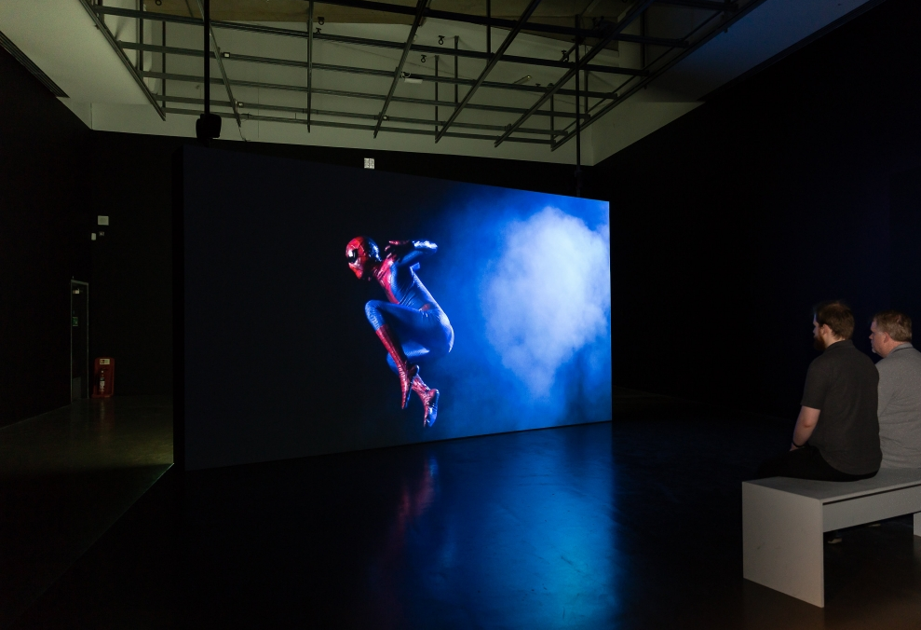

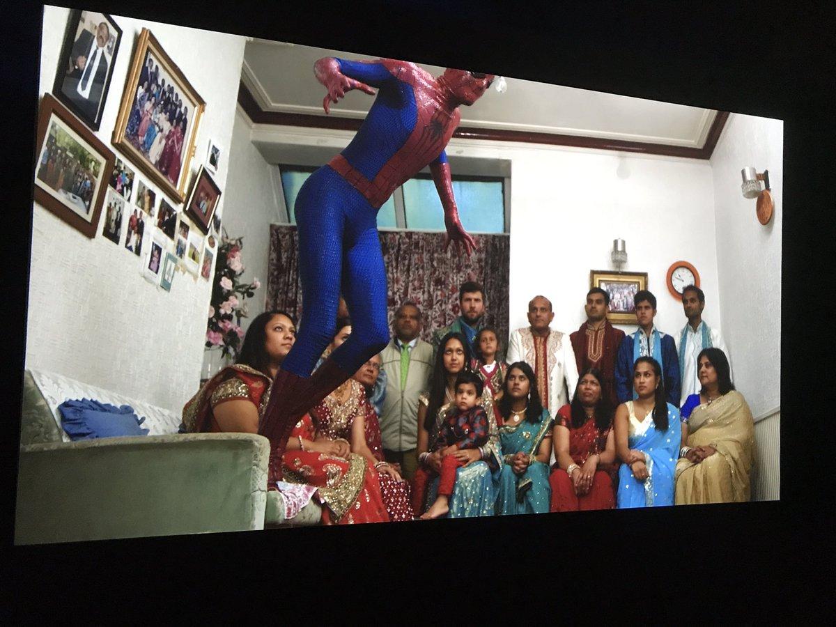

10-11. The Jump. Manchester Museum of Art.

Patel has stated that he has a natural talent for imitation, and his work consists of acting out roles such as Bruce Lee and Al Pacino, or even shaving his head to regrow it in his father’s side parting. He reflected in an interview that growing up in Bolton, UK was an exercise in acting the parts of British and Indian, neither of which he felt comfortable doing, and it was only as he began to act more elaborate roles that he could discover a more unbounded form of expression, such as when he used to impersonate Spiderman as a boy, wearing a makeshift costume and jumping between his grandmother’s sofas. He reprises this role in The Jump (2015), a 6-minute two-channel HD video projection that is installed as two screens placed back to back. Both projections show the artist wearing a replica suit emblazoned with a ‘Letter to Peter Parker’, which thanks the comic book hero for lending the artist his persona. This text is repeated numerous times across the morph suit, performing the same reiterative function as the artist who replicates the identities of his parents and popular cultural icons. The first video, on the verso side of the screen, displays the artist-as-Spiderman jumping in extremely slow motion, leaping into the air in a crouching position and then landing in a squat. This pastiche of a dramatic Hollywood action shot builds dramatic tension through slow motion editing, an epic soundtrack and billowing clouds of dust lit by bright production lighting. The video on the recto side begins with Patel’s extended family wearing traditional Indian dress in his grandmother’s living room, in a tight shot that is barely able to include all family members in one frame. The camera pans slowly from right to left across the seated women and upstanding men, each looking directly at the camera with the exception of a young, distracted cousin. Eventually the artist-as-Spiderman comes into view, crouching on the sofa before once again leaping in slow motion and landing in a squat, as his family looks on, straight-faced.

The first video conforms to the cinematic convention of rendering fiction as truth, that Deleuze describes in Cinema II, employing atmospheric sound, dramatic lighting and high definition projection quality to bring the stunt to life. The work directs the viewer to believe that the superhero action shot is actually taking place in front of them, enhanced by the fact that the screen is installed in a dark room, so that its edge becomes absorbed into the surrounding blackness and the viewer is enveloped in the diegetic world. In the second video, however, the artist jams this mechanism of authenticity. What the viewer was encouraged to believe in the first video is revealed to be mere make-believe, as the superhero story contrasts with the relative true story of the artist’s family. The family in turn refuse to give credence to the image, as they seem uncomfortable in their unnatural poses and ornate wedding outfits, the young cousin restless after a presumably long duration of filming, and the framed family photographs on the wall indicating that this is a mere representation. Patel’s evocation of the powers of the false is to show real characters taking part in a perpetual role-play, and to collapse fact and fiction without becoming subjected to either term. The last image epitomises this ethos: a close-up of the artist-as-Spiderman in a crouched landing position seems to reproduce the closing image of the first video, except that the camera has zoomed in on the morph suit and its biographical inscription. The viewer has a moment to read how Patel related to Spiderman as a boy: ‘thank you for being skinny and wearing glasses’, ‘thank you for being too shy to talk to girls’, ‘thank you for being bullied and having the shit knocked out of you’. The text blends the story of Spiderman with Patel’s real personal experience, just as there is a conflation between Spiderman’s blue and red skin and the artist’s body that provides its volume. By refusing to convey fiction as authentic, and resisting the urge to give truth over entirely to fiction, Patel sets in motion a fabulation that toes the line between fact and fiction to enable a constant becoming. Where his Anglo-Indian identity has been forced into stereotypes, he stops playing by the racist and colonial rules of concocting fictions and arguing truths, opting instead for comingled fiction-facts or fabulations.

Bibliography

Barthes, Roland, Camera Lucida, trans. Richard Howard (London: Macmillan, 1980)
Chatterjee, Partha, The Nation and Its Fragments (New Jersey: Princeton University Press, 1993)
Chaudhary, Zahid, ‘Phantasmagoric Aesthetics: Colonial Violence and the Management of Perception’, Cultural Critique 59 (2005), pp. 63-119.
Dave, Parul, ‘Horn Please’, Horn Please: Narratives in Contemporary Indian Art, ed. Suman Gopinath et. al. (Bern: Kunstmuseum Bern, 2007), pp. 27-31.
Deleuze, Gilles, Cinema II: The Time-Image, trans. Hugh Tomlinson and Robert Galeta (Minneapolis: University of Minnesota Press, 2013)
Drucks, Achim, ‘Five Minutes to Ecstasy: The Raqs Media Collective at Deutsche Bank Birmingham’, Art Mag by Deutsche Bank online resource (2017), <https://db-artmag.com/en/82/feature/five-minutes-to-ecstasy-the-raqs-media-collective-at-deutsche-ba/> [accessed 1 December 2018]
Eaton, Natasha, Colour, Art and Empire (London: IB Tauris, 2013)
Eaton, Natasha, ‘Subaltern rustle: Raqs media collective, the colour blue and the colonial archive’, Marg: A Magazine of the Arts, 67 (2015)
Eisenstein, Sergei, Film Form: Essays in Film Theory, ed. Jay Leyda (New York: HBJ, 1977)
Felski, Rita, The Limits of Critique (Chicago: University of Chicago Press, 2015)
Flaxman, Gregory, Gilles Deleuze and the Fabulation of Philosophy (Minneapolis: University of Minnesota Press, 2011).
Ginzburg, Carlo and Anna Davin, ‘Morelli, Freud and Sherlock Holmes: Clues and Scientific Method’, History Workshop 9 (Spring, 1980), pp. 5-36.
Mackrell, Judith, ‘How Hetain Patel shape-shifted from Spider-Man to bad Obama’, The Guardian (2016), <https://www.theguardian.com/stage/2016/nov/21/hetain-patel-american-man-sadlers-wells> [accessed 1 December 2018]
Maranda, Michael ed., Raqs Media Collective: Casebook (Toronto: Art Gallery of York University, 2014)
Mavor, Carol, Blue Mythologies (Chicago: Reaktion, 2013)
Mulvey, Laura, Death 24x per second (London: Reaktion, 2006)
Pierce, Charles Sanders, The Writings of Charles S. Peirce: A Chronological Edition (Indiana: Indiana University Press, 1984)
Pinney, Christopher, Camera Indica (Chicago: University of Chicago Press, 1997)
Raqs Media Collective, Sarai Reader 3 (Delhi: Autonomedia, 2006)
Raqs Media Collective, ‘In the Theatre of Memory: The Work of Contemporary Art in the Photographic Archive’, Photography in India, eds. Aileen Blaney and Chinar Shah (London: Bloomsbury, 2018), pp. 21-31.
Roy, Arundhati, War Talk (Cambridge: South End Press, 2003)
Said, Edward, Orientalism (New York: Vintage Books, 1979)
Schwartz, Joan M, ‘Records of Simple Truth and Precision: Photography, Archives and the Illusion of Control’, Archivaria 50 (2000), pp. 1-40
Sedgwick, Eve, Touching Feeling: Affect, Pedagogy, Performativity (Durham: Duke University Press, 2003)
Sengoopta, Chandak, Imprint of the Raj (London: Macmillan, 2004)

Edward Said, Orientalism (New York, 1979), p. 204.
Francis Galton quoted in Christopher Pinney, Camera Indica (Chicago, 1997), p. 69.
Friedrich Nietzsche, The Portable Nietzsche, ed. Walter Kaufman (London, 1982), pp. 42-47.
Arundhati Roy, War Talk (Cambridge, MA, 2003), p. 120.
Raqs Media Collective, ‘First Information Report’, The Question of Evidence, eds. Diana Baldon and Daniela Zyman (Vienna, 2008), pp. 78-79.
Partha Chatterjee, The Nation and Its Fragments (New Jersey, 1993)
Hans Ulrich Obrist, ‘Hans Ulrich Obrist in conversation with Raqs Media Collective’, Raqs Media Collective: Casebook, ed. Michael Maranda (Toronto, 2014), p. 140.
Quoted in Philip Monk, ‘The Cipher and the Sieve’, Raqs Casebook, p. 14.
Henceforth referred to as Untold Intimacy.
Quoted in Pinney, Camera Indica, p. 69. See also Chandak Sengoopta, Imprint of the Raj (London, 2004).
Ibid., p. 70.
Natasha Eaton, ‘Subaltern rustle: Raqs media collective, the colour blue and the colonial archive’, Marg: A Magazine of the Arts, 67 (2015).
Carol Mavor, Blue Mythologies (Chicago, 2013), p. 10, emphasis in original.
Eaton, Colour, Art and Empire (London, 2013), p. 35.
Quoted in Sengoopta, Imprint of the Raj, pp. 87-88.
See Raqs Media Collective, ‘A Concise Lexicon of/for the Digital Commons’, Sarai Reader 3 (Delhi, 2006), pp. 357-365.
Interview between Jane DeBevoise and Shuddhabrata Sengupta from Raqs Media Collective at the Asia Art Archive, New York, 9 March 2012.
Gilles Deleuze, Cinema II: The Time-Image, trans. Hugh Tomlinson and Robert Galeta (Minneapolis, 2013), pp. 126-155.
Quoted in Achim Drucks, ‘Five Minutes to Ecstasy: The Raqs Media Collective at Deutsche Bank Birmingham’, Art Mag by Deutsche Bank, online resource (2017)
Rita Felski, The Limits of Critique (Chicago, 2015); Eve Sedgwick, ‘Paranoid Reading and Reparative Reading, or, You’re so Paranoid, You Probably Think This Essay Is About You’, Touching Feeling: Affect, Pedagogy, Performativity (Durham, 2003); and Carlo Ginzburg and Anna Davin, ‘Morelli, Freud and Sherlock Holmes: Clues and Scientific Method’, History Workshop 9 (Spring, 1980), pp. 5-36.
Henceforth referred to as Surface.
Pinney, Camera Indica, pp. 17-71; Joan M Schwartz, ‘Records of Simple Truth and Precision: Photography, Archives and the Illusion of Control’, Archivaria 50 (2000), pp. 1-40; and Zahid Chaudhary, ‘Phantasmagoric Aesthetics: Colonial Violence and the Management of Perception’, Cultural Critique 59 (2005), pp. 63-119.
Roland Barthes, Camera Lucida, trans. Richard Howard (London, 1980), p. 89.
Quoted in Pinney, Camera Indica, p. 21.
Nietzsche, Portable Nietzsche, p. 47.
Laura Mulvey, Death 24x a second (London, 2006), p. 66.
Sergei Eisenstein, Film Form: Essays in Film Theory, ed. Jay Leyda (New York, 1977), p. 37.
Chaudhary, ‘Phantasmagoric Aesthetics’, pp. 63-119.
Barthes, Camera Lucida, p. 79.
Raqs Media Collective, ‘In the Theatre of Memory: The Work of Contemporary Art in the Photographic Archive’, Photography in India, eds. Aileen Blaney and Chinar Shah (London, 2018), p. 25.
See the artist’s TED talk, Hetain Patel, ‘Who am I? Think again’ (2013)
Interview with Judith Mackrell, ‘How Hetain Patel shape-shifted from Spider-Man to bad Obama’, The Guardian (2016)
Deleuze, Cinema II, p. 147.

